Adoption Likelihood Analysis



Stephanie Brannen

Kalisha Hill

Sofia Muller

### The Problem

Certain breeds, ages, sizes and even colors of pets have a harder time getting adopted than others. We want to provide adopters with a tool that provides them with information about which pets are the least likely to be adopted.

### Data Sets

We will use the [Austin Animal Center Intakes and Outcomes](https://data.austintexas.gov/Health-and-Community-Services/Austin-Animal-Center-Intakes/wter-evkm) dataset provided by the City of Austin at data.austintexas.gov. It includes information about approximately 89,570 pets.

Once we finalize this analysis, our hope is to connect the findings to a [deep learning model](https://github.com/fchollet/deep-learning-models/releases/download/v0.4/xception_weights_tf_dim_ordering_tf_kernels.h5). The machine learning model predicts the breed of a pet when a picture is submitted.

### Visualizations

**Stage 1:**

We will analyze the pets that are and have been available for adoption. From the ones that have gone through an Austin shelter, we will analyze the different outcomes. We will breakdown those outcomes by breed, age, color.

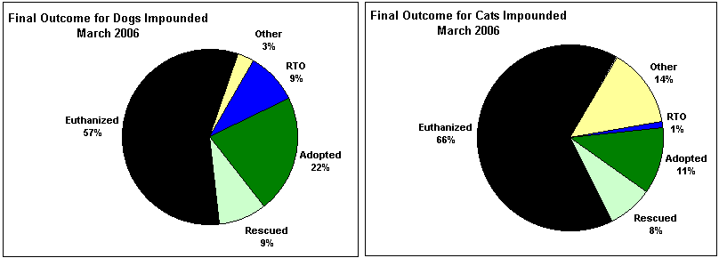

We will analyze which pets are more likely to be adopted and the ones that stay the shortest time at shelters before getting adopted.

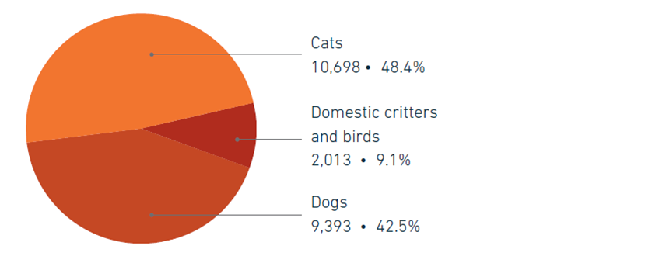

We will analyze surrender and adoption trends over time.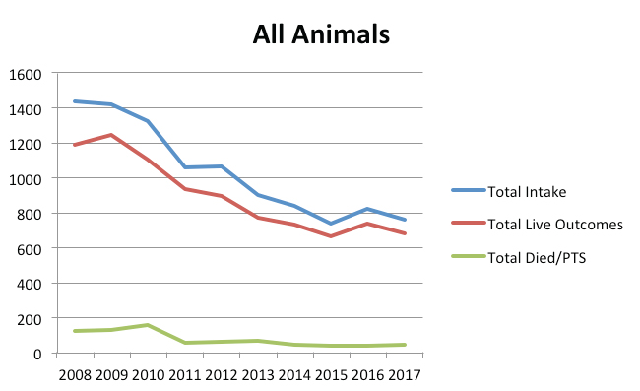

**Stage 2:**

Our goal is to create a webpage in which the user can submit a picture of a pet and get a statistical analysis of adopted and adoptable pets with similar characteristics.

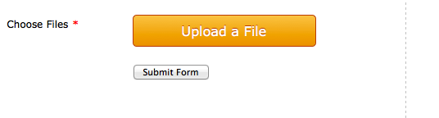

People who are looking to help a pet with the least chances of getting adopted will now have data to back up their decision.

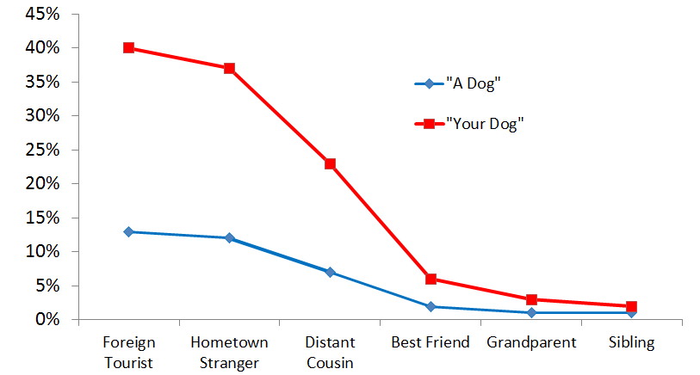

### Design

We hope to keep all the necessary data and information within one webpage. We will present the problem analysis and solution within the webpage.